DYNAMIC MEMORY ALLOCATION:

1)2D ARRAY:

#include<iostream>

using namespace std;

int main()

{

int i,j,rows,cols;

cout<<"enter number of rows";

cin>>rows;

cout<<"enter numnber of cols:";

cin>>cols;

int \*\*a=new int \*[rows];

for(i=0;i<rows;i++)

{

a[i]=new int[cols];

}

cout<<"2d array"<<endl;

for(i=0;i<rows;i++){

for(j=0;j<cols;j++){

cin>>a[i][j];

}

}

cout<<"2d array elements"<<endl;

for(i=0;i<rows;i++){

for(j=0;j<cols;j++){

cout<<a[i][j];

if(j==cols-1)

cout<<endl;

}

}

return 0;

}

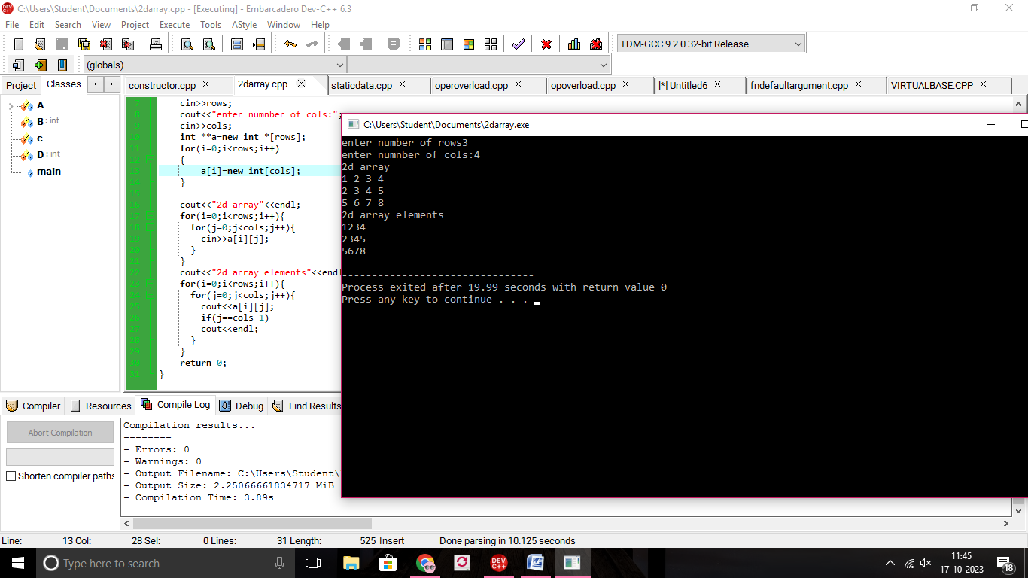

2)STATIC DATA AND MEMBER FUNCTION:

#include<iostream>

using namespace std;

class A

{

public:

int a;

static int b;

void increment1()

{

a=a+10;

b=b+10;

cout<<a<<b;

}

};

int A::b=10;

int main()

{

A A1,A2;

A1.a=10;

A2.a=20;

A1.increment1();

A2.increment1();

return 0;

}

